Section 8. Inspection and Repair of Control Cables

and Turnbuckles

GENERAL. Aircraft control cables are generally fabricated from carbon steel or corrosion-resistant steel wire of either flexible or nonflexible-type construction.

CABLE DEFINITIONS. The following cable components are defined in accordance with Military Specifications MIL-W-83420, MIL-C-18375, and MIL-W-87161.

Wire Center. The center of all strands shall be an individual wire and shall be designated as a wire center.

Strand Center or Core. A strand center is a single, straight strand made of preformed wires, similar to the other strands comprising the cable, in arrangement and number of wires.

Independent wire rope center (IWRC) 7 by 7. A 7 by 7 independent wire rope center as specified herein shall consist of a cable or wire rope of six strands of seven wires each, twisted or laid around a strand center or core consisting of seven wires.

FLEXIBLE CABLES. Flexible, preformed, carbon steel, Type I, composition A cables, MIL-W-83420, are manufactured from steel made by the acid-open-hearth, basic-open hearth, or electric-furnace process. The wire used is coated with pure tin or zinc. Flexible, preformed, corrosion-resistant, Type I, composition B cables, MIL-W-87161, MIL-W-83420, and MIL-C-18375 are manufactured from steel made by the electric-furnace process. (See table 7-3 and figure 7-8.) These cables are of the 3 by 7, 7 by 7, 7 by 19, or 6 by 19 IWRC construction, according to the diameter as specified in table 7-3. The 3 by 7 cable consists of three strands of seven wires each. There is no core in this construction. The 3 by 7 cable has a length of lay of not more than eight times or less than five times the nominal cable diameter. The 7 by 7 cable consists of six strands, of seven wires each, laid around a center strand of seven wires. The wires are laid so as to develop a cable which has the greatest bending and wearing properties. The 7 by 7 cable has a length of lay of not more than eight times or less than six times the cable diameter. The 7 by 19 cable consists of six strands laid around a center strand in a clockwise direction. The wires composing the seven individual strands are laid around a center wire in two layers. The center core strand consists of a lay of six wires laid around the central wire in a clockwise direction and a layer of 12 wires laid around this in a clockwise direction. The six outer strands of the cable consist of a layer of six wires laid around the center wire in a counterclockwise direction and a layer of 12 wires laid around this in a counterclockwise direction. The 6 by 19 cable consists of six strands of 19 wires each, laid around a 7 by 7. MIL-C-18375 cable, although not as strong as MIL-W-83420, is equal in corrosion resistance and superior in non-magnetic and coefficient of thermal expansion properties.

NYLON-COATED CABLES.

Nylon-coated cable is made by extruding a flexible nylon coating over corrosion-resistant steel (CRES) cable. The bare CRES cable must conform and be qualified to MIL-W-83420. After coating, the jacketed cable must still conform to MIL-W-83420.

The service life of nylon-coated cable is much greater than the service life of the same cable when used bare. Most cable wear occurs at pulleys where the cable bends. Wear

Table 7-3. Flexible cable construction and physical properties.
 |  |  |  | MINIMUM BREAKING STRENGTH (Pounds)
NOMINAL  DIAMETER OF WIRE  ROPE  CABLE | CONSTRUCTION | TOLERANCE  ON  DIAMETER  (PLUS ONLY) | ALLOWABLE INCREASE  OF  DIAMETER  AT  CUT END | MIL-W-  83420  COMP A | MIL-W-83420  COMP B  (CRES) | MIL-C-18375  (CRES)
INCHES |  | INCHES | INCHES | LBS | LBS | LBS
1/32  3/64  1/16  1/16  3/32  3/32  1/8  5/32  3/16  7/32  1/4  9/32  5/16  11/32  3/8  7/16  1/2  9/16  5/8  3/4  7/8  1  1 - 1/8  1 - 1/4  1 - 3/8  1 - 1/2 | 3 x 7  7 x 7  7 x 7  7 x 19  7 x 7  7 x 19  7 x 19  7 x 19  7 x 19  7 x 19  7 x 19  7 x 19  7 x 19  7 x 19  7 x 19  6 x 19 IWRC  6 x 19 IWRC  6 x 19 IWRC  6 x 19 IWRC  6 x 19 IWRC  6 x 19 IWRC  6 x 19 IWRC  6 x 19 IWRC  6 x 19 IWRC  6 x 19 IWRC  6 x 19 IWRC | 0.006  0.008  0.010  0.010  0.012  0.012  0.014  0.016  0.018  0.018  0.018  0.020  0.022  0.024  0.026  0.030  0.033  0.036  0.039  0.045  0.048  0.050  0.054  0.057  0.060  0.062 | 0.006  0.008  0.009  0.009  0.010  0.010  0.011  0.017  0.019  0.020  0.021  0.023  0.024  0.025  0.027  0.030  0.033  0.036  0.039  0.045  0.048  0.050  0.054  0.057  0.060  0.062 | 110  270  480  480  920  1,000  2,000  2,800  4,200  5,600  7,000  8,000  9,800  12,500  14,400  17,600  22,800  28,500  35,000  49,600  66,500  85,400  106,400  129,400  153,600  180,500 | 110  270  480  480  920  920  1,760  2,400  3,700  5,000  6,400  7,800  9,000  12,000  16,300  22,800  28,500  35,000  49,600  66,500  85,400  106,400  129,400  153,600  180,500 | 360  700  1,300  2,000  2,900  3,800  4,900  6,100  7,600  11,000  14,900  19,300  24,300  30,100  42,900  58,000  75,200

is caused by friction between strands and between wires. In bare cable, this is aggravated by dirt and grit working its way into the cable; and the lubricant working its way out leaving dry, dirty wires rubbing against each other. In long, straight runs of cable, vibration workhardens the wires causing the brittle wires to fracture with eventual failure of the cable.

The nylon-jacket protects the cable in a threefold manner. It keeps the lubricant from oozing out and evaporating, it keeps dirt and grit out, and it dampens the vibrations, thereby, greatly reducing their effect on the cable.

NONFLEXIBLE CABLES. (Refer to table 7-4 and figure 7-9.) Nonflexible, preformed, carbon steel cables, MIL-W-87161, composition A, are manufactured by the same processes as MIL-W-83420, composition B, flexible corrosion-resistant steel cables. The nonflexible steel cables are of the 1 by 7 (Type I) or 1 by 19 (Type II) construction according to the diameter as specified in table 7-4. The 1 by 7 cable consists of six

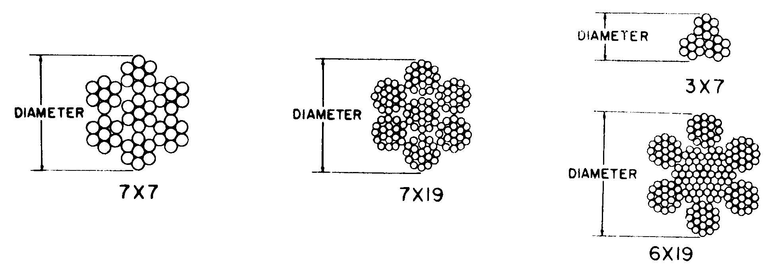
Figure 7-8. Flexible cable cross section.

Table 7-4. Nonflexible cable construction and physical properties.
STRAND  TYPE | NOMINAL  DIAMETER  OF  WIRE  STRAND  In. | TOLERANCE  ON  DIAMETER  (Plus Only)  In. | ALLOWABLE  INCREASE  IN  DIAMETER  AT THE END  In. | CONSTRUCTION | MIL-W-87161  MINIMUM  BREAK  STRENGTH  COMP A & B  Lbs.
I  I  II  I  II  II  II  II  II  II  II  II  II  II  II | 1/32  3/64  3/64  1/16  1/16  5/64  3/32  7/64  1/8  5/32  3/16  7/32  1/4  5/16  3/8 | 0.003  0.005  0.005  0.006  0.006  0.008  0.009  0.009  0.013  0.013  0.013  0.015  0.018  0.022  0.026 | 0.006  0.008  0.008  0.009  0.009  0.009  0.010  0.010  0.011  0.016  0.019  0.020  0.021  0.024  0.027 | 1 x 7  1 x 7  1 x 19  1 x 7  1 x 19  1 x 19  1 x 19  1 x 19  1 x 19  1 x 19  1 x 19  1 x 19  1 x 19  1 x 19  1 x 19 | 185  375  375  500  500  800  1,200  1,600  2,100  3,300  4,700  6,300  8,200  12,500  17,500

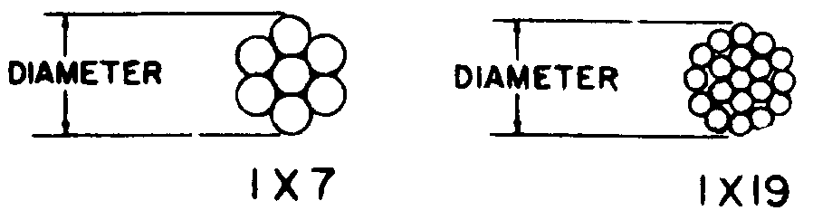
Figure 7-9. Nonflexible cable cross section.

wires laid around a center wire in a counterclockwise direction. The 1 by 19 cable consists of a layer of six wires laid around a center wire in a clockwise direction plus twelve wires laid around the inner strand in a counterclockwise direction.

CABLE SPECIFICATIONS. Cable diameter and strength data are given in table 7-3 and table 7-4. These values are acceptable for repair and modification of civil aircraft.

CABLE PROOF LOADS. Cable terminals and splices should be tested for proper strength before installation. Gradually apply a test load equal to 60 percent of the cable-breaking strengths given in table 7-3 and

table 7-4, for a period of 3 minutes. Place a suitable guard over the cable during the test to prevent injury to personnel in the event of cable failure.

REPLACEMENT OF CABLES. Replace control cables when they become worn, distorted, corroded, or otherwise damaged. If spare cables are not available, prepare exact duplicates of the damaged cable. Use materials of the same size and quality as the original. Standard swaged cable terminals develop the full cable strength and may be substituted for the original terminals wherever practical. However, if facilities and supplies are limited and immediate corrective action is necessary, repairs may be made by using cable bushings, eye splices, and the proper combination of turnbuckles in place of the original installation. (See figure 7-12(c).)

Location of Splices. Locate splices so that no portion of the splice comes closer than 2 inches to any fair-lead or pulley. Locate connections at points where jamming cannot occur during any portion of the travel of either the loaded cable or the slack cable in the deflected position.

Cutting and Heating. Cut cables to length by mechanical means. The use of a torch, in any manner, is not permitted. Do not subject wires and cables to excessive temperature. Soldering the bonding braid to the control cable is not permitted.

Ball-and-Socket Type Terminals. Do not use ball-and-socket type terminals or other types for general replacement that do not positively prevent cable untwisting, except where they were utilized on the original installation by the aircraft manufacturer.

Substitution of Cable. Substitution of cable for hard or streamlined wires will not be acceptable unless specifically approved by a representative of the FAA.

MECHANICALLY-FABRI-CATED CABLE ASSEMBLIES.

Swage-Type Terminals. Swage-type terminals, manufactured in accordance with AN, are suitable for use in civil aircraft up to, and including, maximum cable loads. When swaging tools are used, it is important that all the manufacturers’ instructions, including “go and no-go” dimensions, be followed in detail to avoid defective and inferior swaging. Observance of all instructions should result in a terminal developing the full-rated strength of the cable. Critical dimensions, both before and after swaging, are shown in table 7-5.

Terminals. When swaging terminals onto cable ends, observe the following procedures.

Cut the cable to the proper length allowing for growth during swaging. Apply a preservative compound to the cable ends before insertion into the terminal barrel.

NOTE: Never solder cable ends to prevent fraying, since the presence of the solder will greatly increase the tendency of the cable to pull out of the terminal.

Insert the cable into the terminal approximately 1 inch, and bend toward the terminal, then push the cable end entirely into the terminal barrel. The bending action puts a kink or bend in the cable end, and provides enough friction to hold the terminal in place until the swaging operation can be performed. Bending also tends to separate the strands inside the barrel, thereby reducing the strain on them.

Table 7-5. Straight-shank terminal dimensions. (Cross reference AN to MS: AN-666 to MS 21259, AN-667 to
MS 20667, AN-668 to MS 20668, AN-669 to MS 21260.)
 |  | Before swaging |  |  |  | After swaging
Cable size  (inches) | Wire strands | Outside  diameter | Bore  diameter | Bore  length | Swaging  length | Minimum  breaking  strength  (pounds) | Shank  diameter *
1/16  3/32  1/8  5/32  3/16  7/32  1/4  9/32  5/16  3/8 | 7 x 7  7 x 7  7 x 19  7 x 19  7 x 19  7 x 19  7 x 19  7 x 19  7 x 19  7 x 19 | 0.160  .218  .250  .297  .359  .427  .494  .563  .635  .703 | 0.078  .109  .141  .172  .203  .234  .265  .297  .328  .390 | 1.042  1.261  1.511  1.761  2.011  2.261  2.511  2.761  3.011  3.510 | 0.969  1.188  1.438  1.688  1.938  2.188  2.438  2.688  2.938  3.438 | 480  920  2,000  2,800  4,200  5,600  7,000  8,000  9,800  14,400 | 0.138  .190  .219  .250  .313  .375  .438  .500  .563  .625
*Use gauges in kit for checking diameters.

NOTE: If the terminal is drilled completely through, push the cable into the terminal until it reaches the approximate position shown in figure 7-10. If the hole is not drilled through, insert the cable until the end rests against the bottom of the hole.

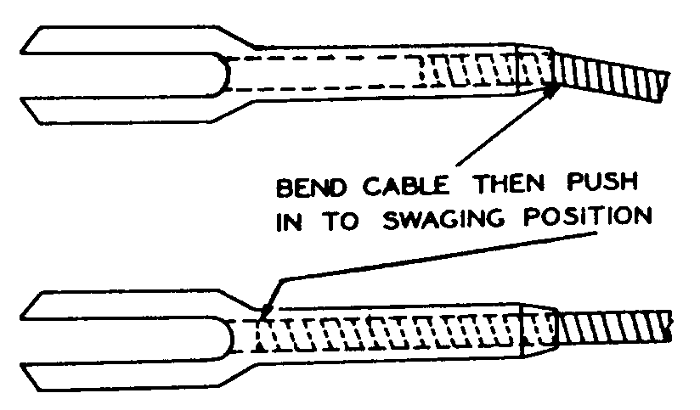
Figure 7-10. Insertion of cable into terminal.

Accomplish the swaging operation in accordance with the instructions furnished by the manufacturer of the swaging equipment.

Inspect the terminal after swaging to determine that it is free from the die marks and splits, and is not out-of-round. Check for cable slippage in the terminal and for cut or broken wire strands.

Using a “go no-go” gauge or a micrometer, check the terminal shank diameter as shown in figure 7-11 and table 7-5.

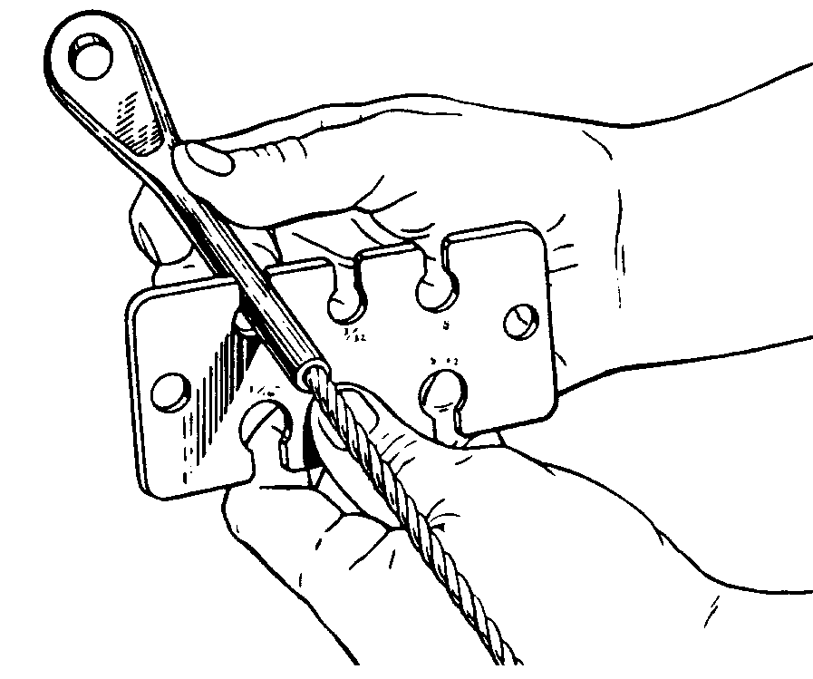
Figure 7-11. Gauging terminal shank after swaging.

Test the cable by proof-loading it to 60 percent of its rated breaking strength.

Splicing. Completely severed cables, or those badly damaged in a localized area, may be repaired by the use of an eye

terminal bolted to a clevis terminal. (See figure 7-12(a).) However, this type of splice can only be used in free lengths of cable which do not pass over pulleys or through fair-leads.

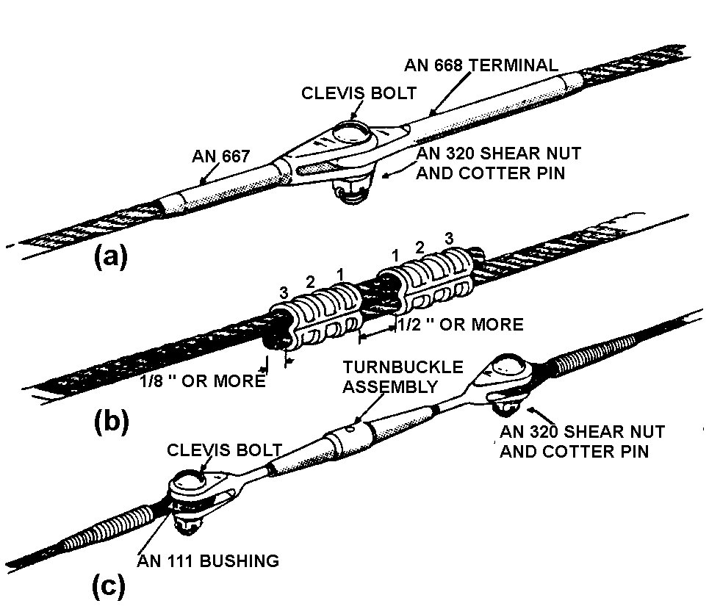

Figure 7-12. Typical cable splices.

Swaged ball terminals. On some aircraft cables, swaged ball terminals are used for attaching cables to quadrants and special connections where space is limited. Single shank terminals are generally used at the cable ends, and double shank fittings may be used at either the end or in the center of the cable. Dies are supplied with the swaging machines for attaching these terminals to cables by the following method.

The steel balls and shanks have a hole through the center, and are slipped over the cable and positioned in the desired location.

Perform the swaging operation in accordance with the instructions furnished by the manufacturer of the swaging equipment.

Check the swaged fitting with a “go no-go” gauge to see that the fitting is properly compressed, and inspect the physical condition of the finished terminal. (See figure 7-13.)
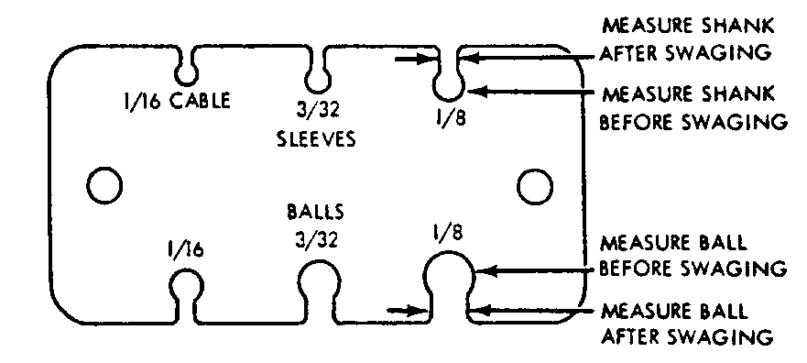
Figure 7-13. Typical terminal gauge.

Cable slippage in terminal. Ensure that the cable is properly inserted in the terminal after the swaging operation is completed. Instances have been noted wherein only 1/4 inch of the cable was swaged in the terminal. Observance of the following precautions should minimize this possibility.

Measure the length of the terminal end of the fitting to determine the proper length of cable to be inserted into the barrel of the fitting.

Lay off this length at the end of the cable and mark with masking tape. Since the tape will not slip, it will provide a positive marking during the swaging process.

After swaging, check the tape marker to make certain that the cable did not slip during the swaging operation.

Remove the tape and paint the junction of the swaged fitting and cable with red tape.

At all subsequent service inspections of the swaged fitting, check for a gap in the painted section to see if cable slippage has occurred.

Nicopress Process. A patented process using copper sleeves may be used up to the full rated strength of the cable when the cable is looped around a thimble. This process may also be used in place of the five-tuck splice on
cables up to and including 3/8 inch diameter. The use of sleeves that are fabricated of materials other than copper will require engineering approval for the specific application by the FAA.

Before undertaking a nicopress splice, determine the proper tool and sleeve for the cable to be used. Refer to table 7-6 and table 7-7 for details on sleeves, tools, and the number of presses required for the various sizes of aircraft cable. The tool must be in good working condition and properly adjusted to ensure a satisfactory splice.

To compress a sleeve, have it well-centered in the tool groove with the major axis of the sleeve at right angles to the tool. If the sleeve appears to be out of line after the press is started, open the tool, re-center the sleeve, and complete the press.

Thimble-Eye Splice. Before undertaking a thimble-eye splice, initially position the cable so the end will extend slightly beyond the sleeve, as the sleeve will elongate somewhat when it is compressed. If the cable end is inside the sleeve, the splice may not hold the full strength of the cable. It is desirable that the oval sleeve be placed in close proximity to the thimble points, so that when compressed, the sleeve will contact the thimble as shown in figure 7-14. The sharp ends of the thimble may be cut off before being used; however, make certain the thimble is firmly secured in the cable loop after the splice has been completed. When using a sleeve requiring three compressions, make the center compression first, the compression next to the thimble second, and the one farthest from the thimble last.

Lap Splice. Lap or running splices may also be made with copper oval sleeves. When making such splices, it is usually necessary to use two sleeves to develop the full

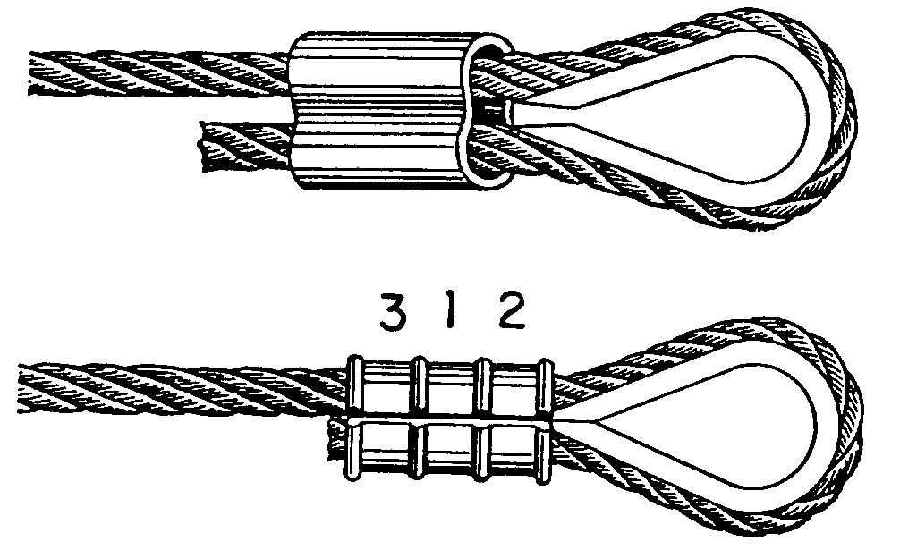
Figure 7-14. Typical thimble-eye splice.

strength of the cable. The sleeves should be positioned as shown in figure 7-12(b), and the compressions made in the order shown. As in the case of eye splices, it is desirable to have the cable ends extend beyond the sleeves sufficiently to allow for the increased length of the compressed sleeves.

Stop Sleeves. Stop sleeves may be used for special cable end and intermediate fittings. They are installed in the same manner as nicopress oval sleeves.

NOTE: All stop sleeves are plain copper. Certain sizes are colored for identification.

Terminal Gauge. To make a satisfactory copper sleeve installation, it is important that the amount of sleeve pressure be kept uniform. The completed sleeves should be checked periodically with the proper gauge. Hold the gauge so that it contacts the major axis of the sleeve. The compressed portion at the center of the sleeve should enter the gauge opening with very little clearance, as shown in figure 7-15. If it does not, the tool must be adjusted accordingly.

Other Applications. The preceding information regarding copper oval sleeves and stop sleeves is based on tests made with flexible aircraft cable. The sleeves may also be
Table 7-6. Copper oval sleeve data.
 | Copper oval sleeve stock No.
Cable size | Plain | Plated* | Manual tool No. | Sleeve length before compression (approx.)  (inches) | Sleeve length after compression (approx.) (inches) | Number of presses | Tested strength (pounds)
3/64 | 18-11-B4 | 28-11-B4 | 51-B4-887 | 3/8 | 7/16 | 1 | 340
1/16 | 18-1-C | 28-1-C | 51-C-887 | 3/8 | 7/16 | 1 | 550
3/32 | 18-2-G | 28-2-G | 51-G-887 | 7/16 | 1/2 | 1 | 1,180
1/8 | 18-3-M | 28-3-M | 51-M-850 | 9/16 | 3/4 | 3 | 2,300
5/32 | 18-4-P | 28-4-P | 51-P-850 | 5/8 | 7/8 | 3 | 3,050
3/16 | 18-6-X | 28-6-X | 51-X-850 | 1 | 1 1/4 | 4 | 4,350
7/32 | 18-8-F2 | 28-8-F2 | 51-F2-850 | 7/8 | 1 1/16 | 4 | 5,790
1/4 | 18-10-F6 | 28-10-F6 | 3-F6-950 | 1 1/8 | 1 1/2 | 3 | 7,180
5/16 | 18-13-G9 | 28-13-G9 | 3-G9-950 | 1 1/4 | 1 5/8 | 3 | 11,130
No. 635
Hydraulic tool dies
3/8 | 18-23-H5 | 28-23-H5 | Oval H5 | 1 1/2 | 1 7/8 | 1 | 16,800
7/16 | 18-24-J8 | 28-24-J8 | Oval J8 | 1 3/4 | 2 1/8 | 2 | 19,700
1/2 | 18-25-K8 | 28-25-K8 | Oval K8 | 1 7/8 | 2 1/2 | 2 | 25,200
9/16 | 18-27-M1 | 28-27-M1 | Oval M1 | 2 | 2 5/8 | 3 | 31,025
5/8 | 18-28-N5 | 28-28-N5 | Oval N5 | 2 3/8 | 3 1/8 | 3 | 39,200
*Required on stainless cables due to electrolysis caused by different types of metals.

Table 7-7. Copper stop sleeve data.

Cable size (inch) | Sleeve No. | Tool No. | Sleeve | Sleeve | Tested strength (pounds)
3/64 | 871-12-B4 | 51-B4-887 | 7/32 | 11/64 | 280
1/16 | 871-1-C | 51-C-887 | 7/32 | 13/64 | 525
3/32 | 871-17-J  (Yellow) | 51-MJ | 5/16 | 21/64 | 600
1/8 | S71-18-J  (Red) | 51-MJ | 5/16 | 21/64 | 800
5/32 | 871-19-M | 51-MJ | 5/16 | 27/64 | 1,200
3/16 | 871-20-M  (Black) | 51-MJ | 5/16 | 27/64 | 1,600
7/32 | 871-22-M | 51-MJ | 5/8 | 7/16 | 2,300
1/4 | 871-23-F6 | 3-F6-950 | 11/16 | 21/32 | 3,500
5/16 | 871-26-F6 | 3-F6-950 | 11/16 | 21/32 | 3,800
NOTE: All stop sleeves are plain copper. Certain sizes are colored for identification.

used on wire ropes of other construction, if each specific type of cable is proof-tested initially. Because of variation in rope strengths, grades, construction, and actual diameters, the test is necessary to insure proper selection of materials, the correct pressing procedure, and an adequate margin of safety for the intended use.

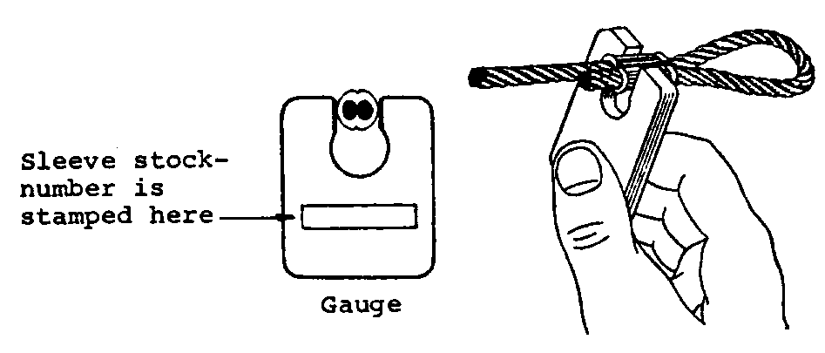
Figure 7-15. Typical terminal gauge.

CABLE SYSTEM INSPECTION. Aircraft cable systems are subject to a variety of environmental conditions and deterioration. Wire or strand breakage is easy to visually recognize. Other kinds of deterioration such as wear, corrosion, and/or distortion are not easily seen; therefore, control cables should be removed periodically for a more detailed inspection.

At each annual or 100 hour inspection, all control cables must be inspected for broken wires strands. Any cable assembly that has one broken wire strand located in a critical fatigue area must be replaced.

A critical fatigue area is defined as the working length of a cable where the cable runs over, under, or around a pulley, sleeve, or through a fair-lead; or any section where the cable is flexed, rubbed, or worked in any manner; or any point within 1 foot of a swaged-on fitting.

A swaged-on fitting can be an eye, fork, ball, ball and shank, ball and double shank, threaded stud, threaded stud and turnbuckle, compression sleeve, or any hardware used as a termination or end fitting on the cable. These fittings may be attached by various swaging methods such as rotary swaging, roll swaging, hydraulic pressing, and hand swaging tools. (See MIL-T-781.) The pressures exerted on the fittings during the swaging process sometimes pinch the small wires in the cable. This can cause premature failure of the pinched wires, resulting in broken wires.

Close inspection in these critical fatigue areas, must be made by passing a cloth over the area to snag on broken wires. This will clean the cable for a visual inspection, and detect broken wires if the cloth snags on the cable. Also, a very careful visual inspection

must be made since a broken wire will not always protrude or stick out, but may lie in the strand and remain in the position of the helix as it was manufactured. Broken wires of this type may show up as a hairline crack in the wire. If a broken wire of this type is suspected, further inspection with a magnifying glass of 7 power or greater, is recommended. Figure 7-16 shows a cable with broken wires that was not detected by wiping, but was found during a visual inspection. The damage became readily apparent when the cable was removed and bent as shown in figure 7-16.

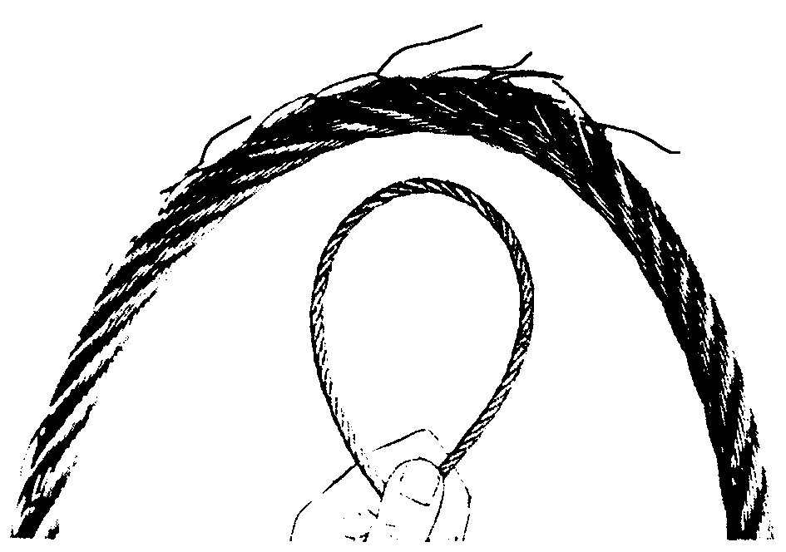
Figure 7-16. Cable inspection technique.

Kinking of wire cable can be avoided if properly handled and installed. Kinking is caused by the cable taking a spiral shape as the result of unnatural twist. One of the most common causes for this twist is improper unreeling and uncoiling. In a kinked cable, strands and wires are out of position, which creates unequal tension and brings excessive wear at this part of the cable. Even though the kink may be straightened so that the damage appears to be slight, the relative adjustment between the strands has been disturbed so that the cable cannot give maximum service and should be replaced. Inspect cables for a popped core or loose strands. Replace any cable that has a popped core or loose strands regardless of wear or broken wires.

Nylon-jacketed cable with any cracks or necking down in the diameter of the jacket shall be replaced. Usable cable life is over when these conditions begin to appear in the nylon jacket.

External wear patterns will extend along the cable equal to the distance the cable moves at that location and may occur on one side of the cable or on its entire circumference. Replace flexible and nonflexible cables when the individual wires in each strand appear to blend together (outer wires worn 40 to 50 percent) as depicted in figure 7-17. Actual instances of cable wear beyond the recommended replacement point are shown in figure 7-18.

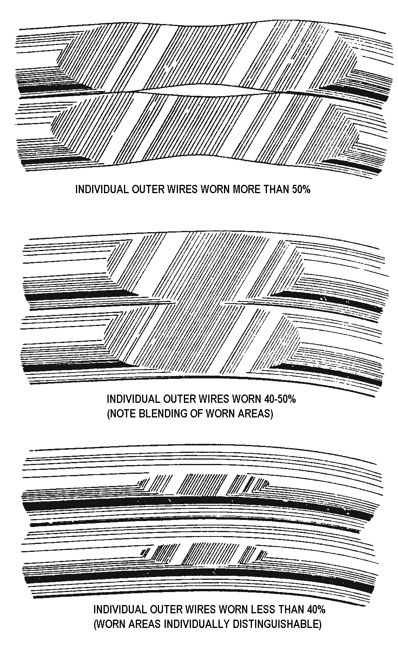
Figure 7-17. Cable wear patterns.

As wear is taking place on the exterior surface of a cable, the same condition is taking place internally, particularly in the sections of the cable which pass over pulleys and quadrants. This condition (shown in figure 7-19) is not easily detected unless the strands of the cable are separated. This type of wear is a result of the relative motion between inner wire surfaces. Under certain conditions, the rate of this type of wear can be greater than that occurring on the surface.

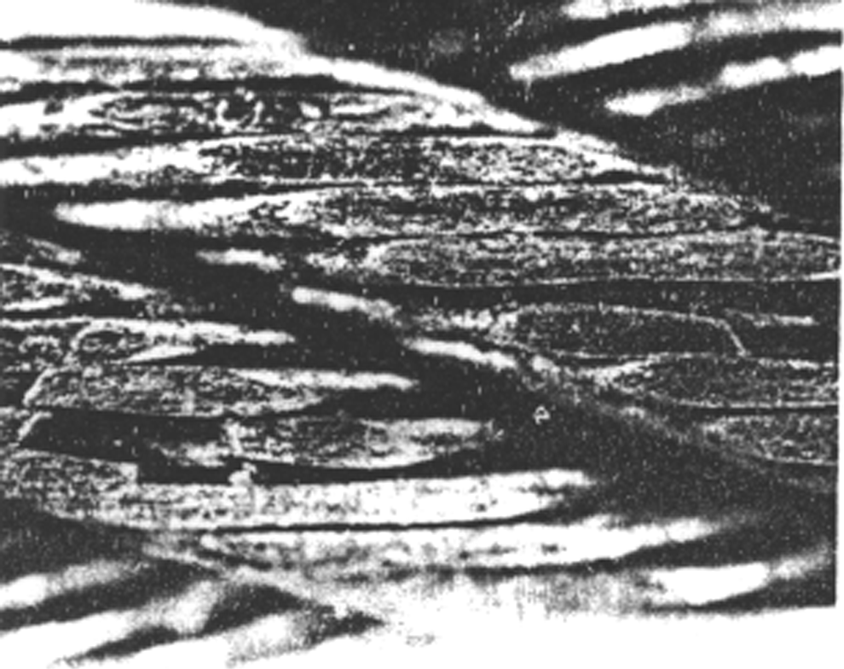
Figure 7-18. Worn cable (replacement necessary).

Areas especially conducive to cable corrosion are battery compartments, lavatories, wheel wells, etc.; where a concentration of corrosive fumes, vapors, and liquids can accumulate. Carefully examine any cable for corrosion, when it has a broken wire in a section that is not in contact with a wear-producing airframe component, such as a pulley, fair-lead, etc. If the surface of the cable is corroded, relieve cable tension and carefully force the cable open by reverse twisting and visually inspect the interior. Corrosion on the interior strands of the cable constitutes failure, and the cable must be replaced. If no internal corrosion is detected, remove loose external rust and corrosion with a clean, dry, coarse-weave rag, or fiber brush. Do not use metallic

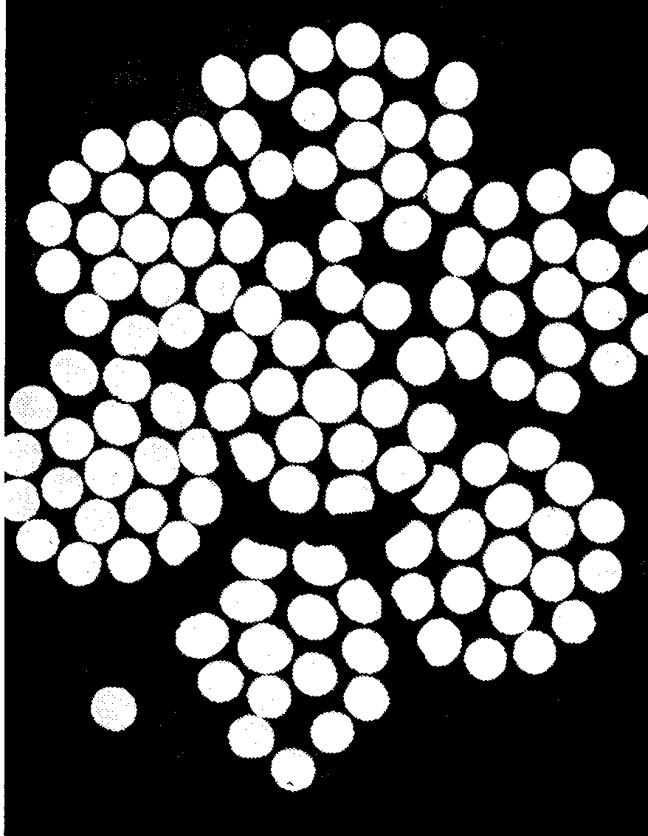
Figure 7-19. Internal end view of cable wear.

wool or solvents to clean installed cables. Use of metallic wool will embed dissimilar metal particles in the cables and create further corrosion problems. Solvents will remove internal cable lubricant allowing cable strands to abrade and further corrode. After thorough cleaning, sparingly apply specification MIL-C-16173, grade 4, corrosion-preventive compound to cable. Do not apply the material so thick that it will interfere with the operation of cables at fair-leads, pulleys, or grooved bellcrank areas.

Examine cable runs for incorrect routing, fraying, twisting, or wear at fair-leads, pulleys, antiabrasion strips, and guards. Look for interference with adjacent structure, equipment, wiring, plumbing, and other controls. Inspect cable systems for binding, full travel, and security of attaching hardware. Check for slack in the cable system by attempting to move the control column and/or pedals while the gust locks are installed on the control surfaces. With the gust locks removed, actuate the controls and check for friction or hard movement. These are indications that excessive cable tension exists.

NOTE: If the control movement is stiff after maintenance is performed on control surfaces, check for parallel cables twisted around each other, or cables connected in reverse.

Check swaged terminal reference marks for an indication of cable slippage within the fitting. Inspect the fitting assembly for distortion and/or broken strands at the terminal. Ensure that all bearings and swivel fittings (bolted or pinned) pivot freely to prevent binding and subsequent failure. Check turnbuckles for proper thread exposure and broken or missing safety wires/clips.

Inspect pulleys for roughness, sharp edges, and presence of foreign material embedded in the grooves. Examine pulley bearings to ensure proper lubrication, smooth rotation; and freedom from flat spots, dirt, and paint spray. During the inspection, rotate the pulleys, which only turn through a small arc, to provide a new bearing surface for the cable. Maintain pulley alignment to prevent the cable from riding on the flanges and chafing against guards, covers, or adjacent structure. Check all pulley brackets and guards for damage, alignment, and security.

Various cable system malfunctions may be detected by analyzing pulley conditions. These include such discrepancies as too much tension, misalignment, pulley bearing problems, and size mismatches between cables and pulleys. Examples of these condition are shown in figure 7-20.

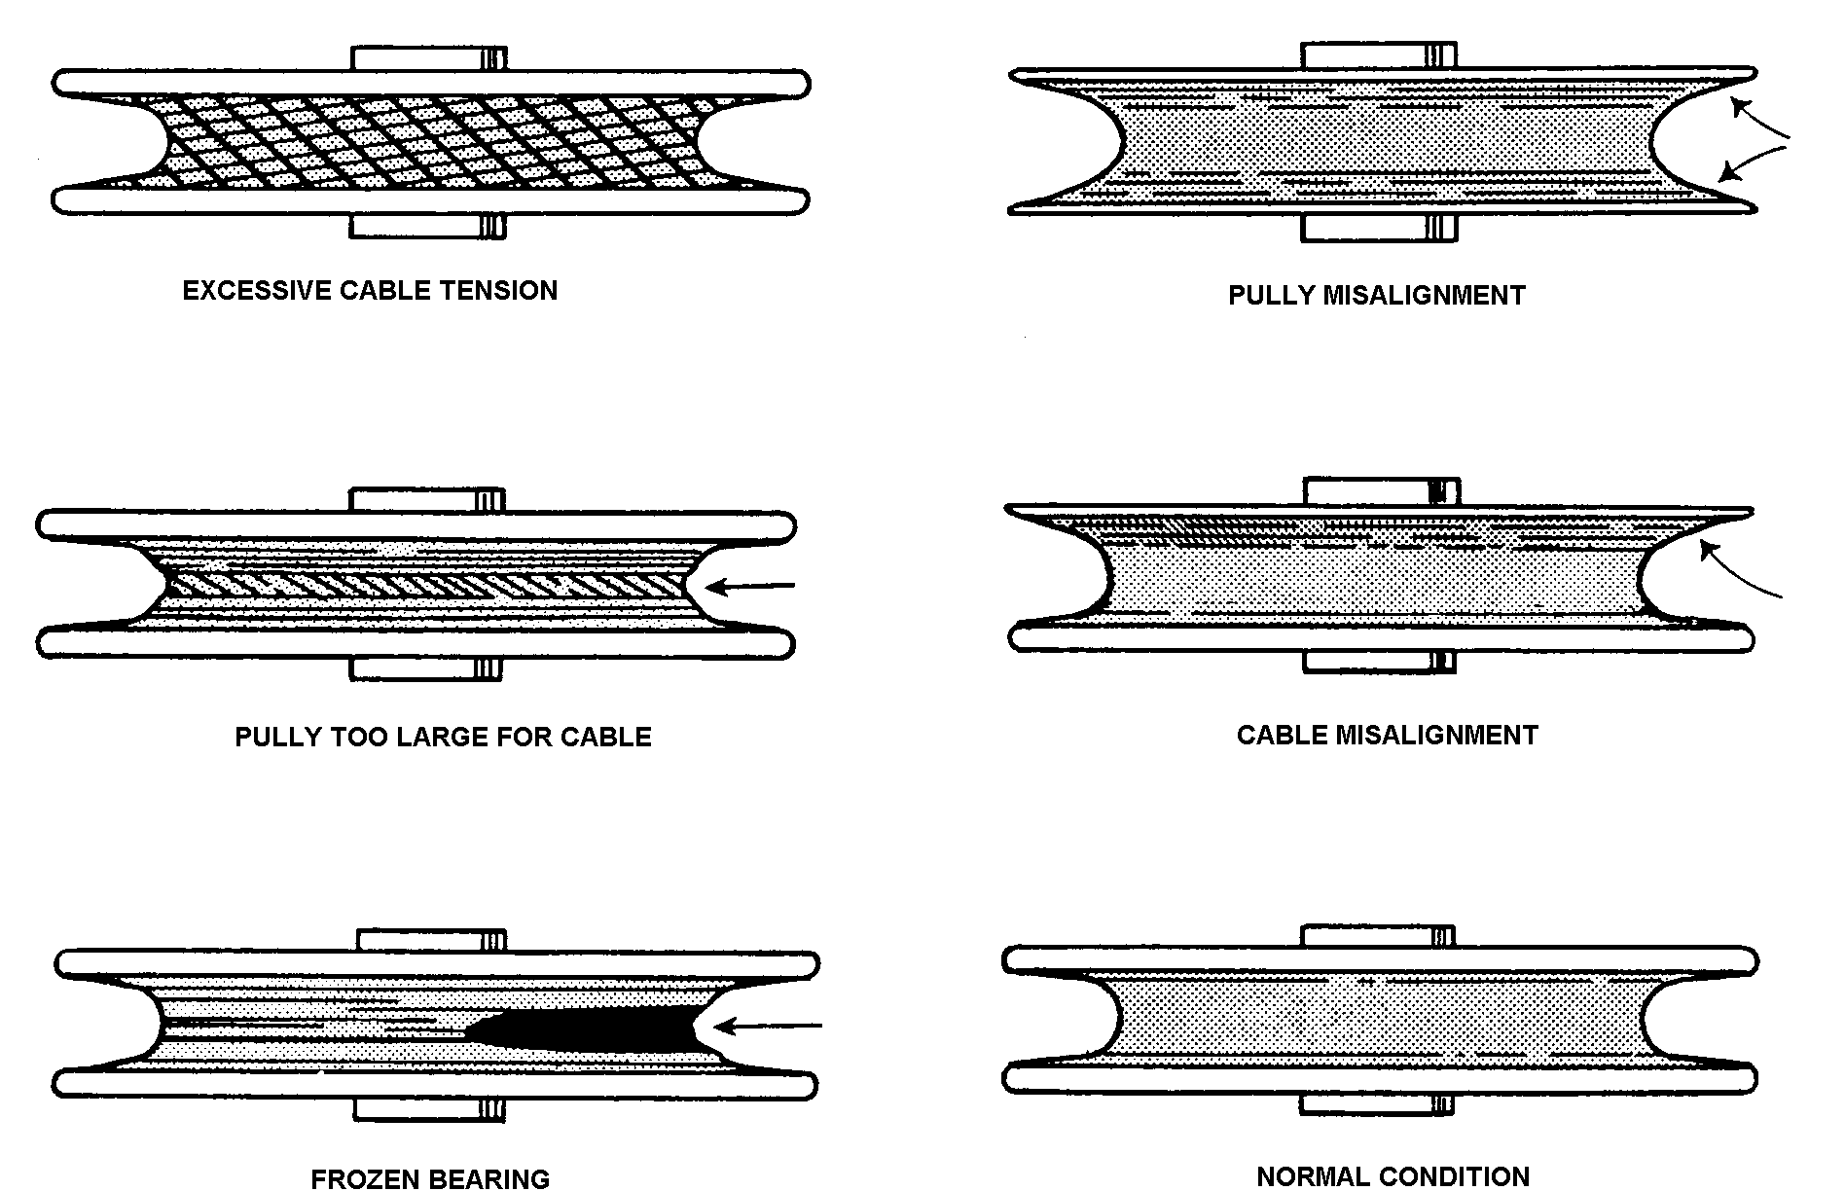

Figure 7-20. Pulley wear patterns.

Inspect fair-leads for wear, breakage, alignment, cleanliness, and security. Examine cable routing at fair-leads to ensure that defection angles are no greater than 3°€maximum. Determine that all guides and anti-abrasion strips are secure and in good condition.

Examine pressure seals for wear and/or material deterioration. Seal guards should be positioned to prevent jamming of a pulley in case pressure seal fails and pieces slide along the cable.

CORROSION AND RUST PRE-VENTION. To ensure a satisfactory service life for aircraft control cables, use a cable lubricant to reduce internal friction and prevent corrosion.

If the cable is made from tinned steel, coat the cable with rust-preventive oil, and

wipe off any excess. It should be noted that corrosion-resistant steel cable does not require this treatment for rust prevention.

Lubrication and corrosion preventive treatment of carbon steel cables may be effected simultaneously by application of compound MIL-C-16173, grade 4, or MIL-C-11796, Class I. MIL-C-16173 compound should be brushed, sprayed, or wiped on the cable to the extent it penetrates into the strands and adequately covers the cable surfaces. It will dry “tack free” in 24 hours at 77 °F. MIL-C-11796 compound is applied by dipping the cable for 1/2 minute into a tank of compound heated to 77 ° ± 5 °C (170 ° ± 9 °F) for 1/2 minute then removing it and wiping off the excess oil. (An example of cable corrosion, attributable to battery acid, is shown in figure 7-21.)

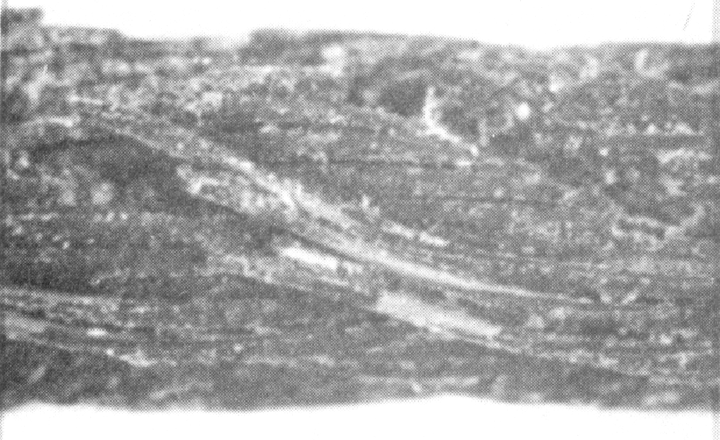
Figure 7-21. Corrosion.

WIRE SPLICES. Standard manufacturing splices have been mistaken for defects in the cable because individual wire end splices were visible after assembly of a finished cable length. In some instances, the process of twisting outer strands around the core strand may also slightly flatten individual outer wires, particularly in the area of a wire splice. This flattening is the result of die-sizing the cable, and does not affect the strength of the cable. These conditions (as shown in figure 7-22) are normal, and are not a cause for cable rejection.

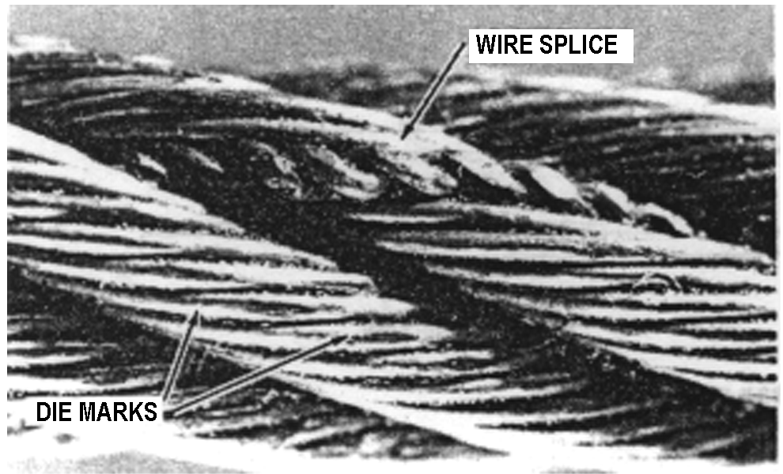
Figure 7-22. Manufacturer’s wire splice.

CABLE MAINTENANCE. Frequent inspections and preservation measures such as rust-prevention treatments for bare carbon steel cable areas, will help to extend cable service life. Where cables pass through fair-leads, pressure seals, or over pulleys, remove accumulated heavy coatings of corrosion-prevention compound. Provide corrosion protection for these cable sections by lubricating with a light coat of grease or general-purpose, low-temperature oil.

CABLE TENSION ADJUST-MENT. Carefully adjust, control cable tension in accordance with the airframe manufacturer’s recommendations. On large aircraft, take the temperature of the immediate area into consideration when using a tension meter. For long cable sections, use the average of two or three temperature readings to obtain accurate tension values. If necessary, compensate for extreme surface temperature variations that may be encountered if the aircraft is operated primarily in unusual geographic or climatic conditions such as arctic, arid, or tropic locations. Use rigging pins and gust locks, as necessary, to ensure satisfactory results. At the completion of rigging operations, check turnbuckle adjustment and safetying in accordance with section 10 of this chapter.

7-154.⎯7-164. [RESERVED.]

