SOAPA 2010 – Spring Break for Pilots @ Sun N’ Fun Lakeland, Florida
April 12 – 14, 2010 (Or Stay for the Entire Week)
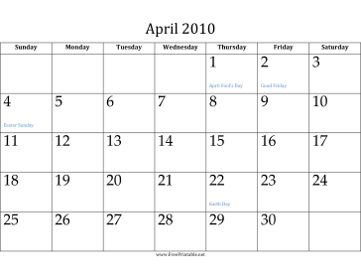 Monday 4/12/2010
Arrive EVB New Smyrna Beach Airport and stay Overnight (Daytona Beach)
6 PM Sunset drinks, seafood dinner, island music, and Arrival briefing To Sun 'N Fun
Tuesday 4/13/2010
Fly to LAL Sun 'N Fun in the morning as a group, mass arrival
6 PM: Skymaster Happy Hour at the Sun 'N Fun Sunset Grill
Wednesday 4/14/2010
Morning: Field trip to the seaplane fly-in lake Afternoon: 2 PM - TENT 11 Shoot the Bull session and Cessna SID Update
Evening: Cook-out at the Skymaster Tents Camping area; business meeting.
Thursday, Friday, Saturday 4/15-17/2010
Depart if you must or ………………….Enjoy Sun N’ Fun for the rest of the week
Please visit www.sun-n-fun.org for all information, notams, arrival procedures, camping reservations, hotel accommodations, etc. Plans should be made ASAP.
If you have questions call Paul Rooy at (386) 258-5008 for information and details

