Richard R. Jackson Jr.
Contact Information: gryphonakymaster@gmail.com 2078501540 (H) 6037176839 (C)
Address: 41 Cross Rd, Shapleigh, ME 04076

Pilot and Aviation Project Manager, Aerial Surveillance, Security & Intelligence Systems Technologies-U.S., LLC. Concord NH – ASSIST-US.COM
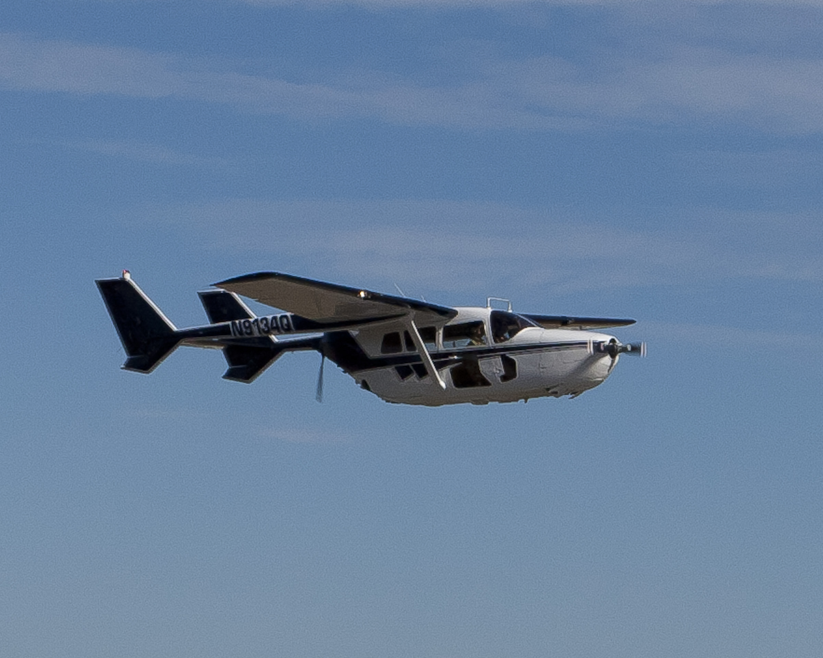

Prior Work Experience:

AirScan Inc. Pilot & Theater Manager (TM) for Reconnaissance/Surveillance/Target Acquisition (RSTA) - Intelligence, Surveillance, Reconnaissance (ISR), AirScan Inc, Operation Iraqi Freedom, Iraq. October 2005 to March 2007, November 2007 to September 2011. Flying MC-337 & PA-31.
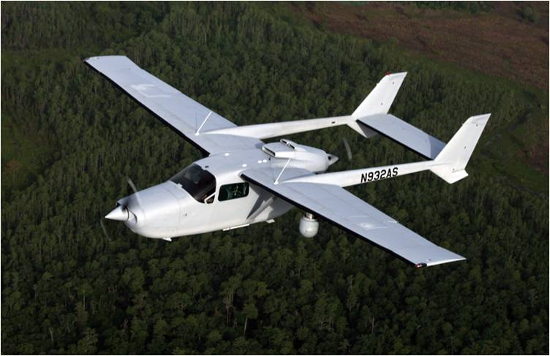

Piasecki Aircraft Experimental Test Pilot. X-49A Speedhawk, experimental compound helicopter. Evaluate and develop SpeedHawk. February - NOV 2007. Flying the X-49A & C-337
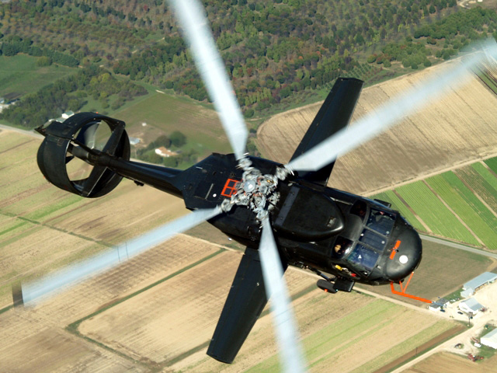

Agusta-Westland NA Tactical-Reconnaissance Helicopter Training, Sales and Instruction for OT&E MH-68/Agusta-109E Series Aircraft. Flying MH-68
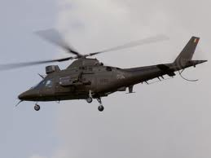

Flight Designations:

USCG: Aircraft Commander, Flight Instructor, & Airborne Use of Force Standardization -Evaluation Examiner
USN: Flight Instructor, Maintenance Test Pilot, and Tactical Formation Instructor
USAF: Aircraft Commander, Combat Air Tactics Instructor and Functional Check Flight pilot.
USA: Rotary Wing Aviator
FAA: Commercial/Instrument/Multi-Engine - Fixed and Rotary Wing
Flight Time: 10000 hrs Military: 5450+ NVG: 1400+ Civil: 4800+

Education/Accreditation/ Clearance:
BA in Mathematics 1983, Northeastern University.
MAS in Aeronautical Science. 1986 Embry-Riddle Aeronautical University
Strategy and Policy, 1996, Naval War College
Amphibious Warfare School, 1994, Marine Corp Institute
Warfare Skills, 1991, Marine Corp Institute
Squadron Officer School, 1984, Air Force University
American College Forensic Examiners International, Certified Homeland Security Level III 2003
DoD Information Systems Security Certified
Clearance: Top Secret/SCI

Service: Commander (O-5), USCG Retired. 22 years of service. Inter-service transfer from USAF,
Captain, (O-3) 1981-1988. Active Service 17 March 1983 to 2 October 2004. Fixed and Rotary Wing Pilot.

Advanced/Specialized Training:
USN TPS FAM "Short Course" Course (TH-6 & F-18), NAS Pautuxent River, 2003
DOD Terrorism Awareness Course Level I 2002
Agusta 109 Factory/MH-68A CG Transition HITRON Courses. 2000.
Command Intelligence Officer School, CG Training Center, 1999.
USN Aircraft & Ship Firefighting, Damage Control Schools, ATG Pearl Harbor, HI, 1996.
USAF Arctic Survival Program, Elmendorf AFB, AK. 1995.
USN Flight Safety Officer School, Navy Post Graduate School, Monterey, CA 1994.
USN Jet Trainer Training, TA-4J, NAS Meridian, MS
CTW-5 Fixed Wing Maintenance Test and Evaluation Course (CTW-5) 1993
USN Fixed Wing Flight Instructor Unit. T-34C Flight Instructor Course. (CTW-5) 1992.
USN Aviation Schools Command. Flight Instructor Training Course. (CNATRA) 1992.
USN Strike Warfare Center. Strike-Rescue Training. (CAW-8 PDWU) 1990.
USCG Aviation Training Center. HH-65 Transition Course. 1989. Requalification Course. 1996.
Allied Air Forces Central Europe (NATO) at Jever Airbase, FRG. Tactical Leadership Program. 1986.
NATO Operation “Chopper Girl”, Helicopter Air to Air/Air to Ground tactical ops, initial cadre. 1986.
USAFE Air to Ground Operations School. Close Air Support Course. (USAFE) 1986.
USAF Combat Air Tactics School. Combat Air Tactics Instructor. (USAF, TAC) 1985.
NATO/USSOC SERE Training Operation Fleet Deer, Bad Toltz, FRG. 1985.
USAFE Air to Ground Operations School. Joint Combat Operations Specialist Course. (USAFE) 1984.
USAF 1550th Aircrew Test and Training Wing. H-53 Transition. (USAF) 1984.
USAF Aircrew Survival School. Survival, Evasion, Resistance, and Escape. (USAF) 1984.

