ABBREVIATED FLIGHT INSTRUCTIONS
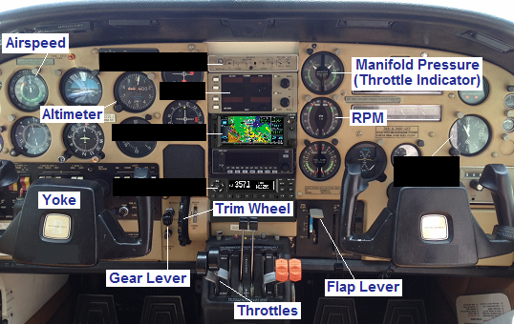
These instructions show how to fly and land the airplane. You should familiarize yourself with the items labeled in the picture at right and with the text below, and we’ll then go flying. Key Points, listed immediately after each Section heading, are non-obvious.

To start you need to know these rules:
- Control the aircraft gently, without strong motions. Your turns, your climbs and your descents, using the yoke, should be gentle.
- Maintain at least 90 knots, especially in the climbs when your speed drops (drops rapidly if it’s too steep instead of gentle).
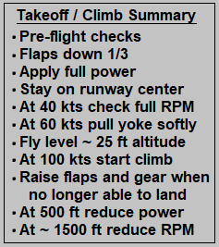

Section 1: Take off and climb (Key Points: Stay initially ~ 25 feet above runway. Raise flaps and landing gear when no longer able to land. Reduce throttle and RPM at 500 feet.)

Before takeoff a dozen checks are crucial to ensure the aircraft is safe to fly. Most important is checking that there is no water in the fuel (by draining a bit of fuel from each wing into a clear container) and checking that both magnetos are working on each engine. After starting engines, you set flaps at 1/3, pushing the Flap Lever down with slight pressure to the left until it hits the first stop. These things are best covered on the actual aircraft.

When tower clears you for takeoff, you line up on the runway and apply full throttle first to rear engine and then to front engine. On the ground you use rudder (bottom of pedals) to stay on centerline. At an airspeed around 40 knots confirm that RPM is near the top of the range for both engines. At about 60 knots start applying gentle pressure back on the yoke. Aircraft should leave the ground shortly thereafter. Crucial that the climb is gentle – too steep is dangerous. When you’re about 20 feet from the ground push yoke in softly to try to arrest the climb and fly level at 20 – 30 feet above the ground. Maintain this level flight for perhaps half a minute until airspeed has risen to 100 knots. Then pull back on the yoke softly to return to a gentle climb so that the airspeed stays at 100 knots (if speed starts dropping, your climb is too steep, if it starts rising, your climb is too shallow).
IMPORTANT
This was written for the author’s use and may contain errors. Use at our own risk.
When you’re in the gentle climb and no longer able to land on the runway, raise flaps (lever all the way up) and raise landing gear by pulling the Gear Lever out towards you about ¼ inch, raising it to the top and releasing it, and then looking to make sure the yellow light goes on a few seconds later, thus confirming full retraction. After flap and gear retraction, adjust climb angle to maintain 100 knots speed.

At 500 feet bring the 2 throttle levers back gently until the Throttle Indicator shows a manifold pressure of 25 on both engines and bring the 2 levers with the crowns (next to the throttle levers) back gently until both engines show 25 on the RPM gauge – this is done because the engines can operate at full power for only a few minutes. Continue climbing to desired altitude at an airspeed of 100 knots. At 1,000 – 2,000 feet reduce engine RPM to 24 (throttle manifold pressure will have normally reduced and should already be at or below 24, so it needs no further adjustment).

Section 2: Level Flight and turns (Key Points: Trim the aircraft. The horizon is your best instrument. Gentle turns. Release yoke after turn starts.)

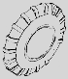
At desired altitude, push yoke to arrest climb and achieve level flight. And we’ll do 2 other things. First, we’ll close the cowl flaps (openings around the engines for higher cooling airflow when the engines were working hard and the aircraft speed was slower) using the short levers to the left of the Gear Lever (I’ll show you how). Second, we’ll use the Trim Wheel, so you don’t have to keep pressure on the yoke. The top of this wheel works as the yoke, with one important difference: it stays put without any pressure from you.

Next we’ll adjust the mixture of fuel and air feeding the engines using the two levers with the red plastic handles next to the crowned levers used to adjust RPM. We need to pull them back a bit to feed less fuel now that the air density has decreased at altitude. This is best shown on the aircraft.

The best indicator of what your aircraft is doing is the horizon. If you’re climbing, you’ll see more of the sky, if you’re descending, more of the ground, and if you are turning, the horizon will be tilted relative to the airplane. Make sure you always see the horizon – don’t climb or descend so steeply that you lose the horizon.

Now let’s practice turns. To turn left you turn the yoke slightly to the left and press the bottom of the left pedal even more softly, very slightly. Turning gently means that the wings are only slightly banked as you turn, so the horizon appears at only a slight angle to the horizontal. Also, check your altitude because there is a tendency to lose some, so you might have to pull the yoke in just a bit. You don’t need to keep the yoke turned and the pedal pressed through the whole turn as you do in a car. As soon as the plane has the correct (gentle) bank angle, release the pedal and return the yoke to its neutral position. The plane will keep turning. Soon the turn/bank angle will diminish, so you give it a bit of yoke/pedal pressure and return to neutral position, and you keep doing this as needed. Slightly before you get to the compass heading you want, you stop the turn by turning in the opposite direction.
IMPORTANT
This was written for the author’s use and may contain errors. Use at our own risk.

Section 3: Descent to land (Key Points: Descend at 500 ft/min. Don’t overspeed. Enrich the fuel mixture.)

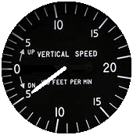
Heading to the landing airport, you’d call the airport tower (or the Common frequency if it’s an uncontrolled airport without a tower) by pressing the talk button on the back of the yoke. Then the plan is to descend so we are at 1,000 feet about 10 miles out from the airport, heading for a runway into the wind.

To descend you want to push the yoke or the top of the Trim Wheel forward and look at the vertical speed indicator that is below the Altimeter to attain and maintain 500 ft/min down. Your speed will slowly increase. Watch the Airspeed to stay within the green arc so you don’t overspeed (yellow and red arcs); if you do, reduce throttle slightly to maintain 500 ft/min but within the green airspeed band.

When you’ve descended 1,000 feet move the red mixture levers to full forward (to enrich the fuel mixture now that air density will increase at a lower altitude). When you’ve descended TO 1,000-1,100 feet, regain level flight (by pulling the yoke back) and re-trim the aircraft. Now adjust throttle to achieve and maintain 100 knots.

Section 4: Landing advanced preparations (Key Point: Know where all the controls are.)

When you’re ready to land you’ll need to find certain things. The wing flaps will slow down the plane for landing, allowing it to fly much slower without falling, down to 70 knots. The landing gear lever we’ll need to lower the gear for landing. And once on the ground you’ll use the pedals to steer (to remain on the runway center) and to brake. As a final check look again at the image on page 1 to make sure you can quickly find the Airspeed Indicator, the Altimeter, the throttle and RPM levers, the Throttle Indicator that shows manifold pressure, the Trim Wheel, the Flaps Lever, and the Landing Gear Lever and lights.
IMPORTANT
This was written for the author’s use and may contain errors. Use at our own risk.

Final Section: Approach and landing (Key Point: Watch your speed.)

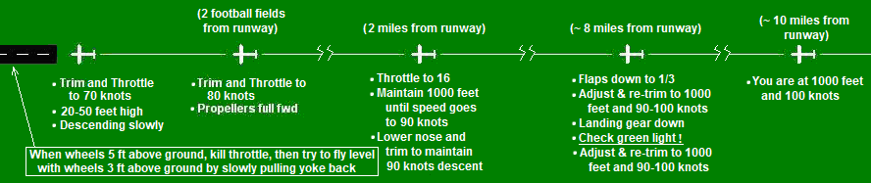
The figure below shows what you’ll be doing to land. Read the text on the figure, working from right to left. The figure starts when you’re about 10 miles out, heading for a runway into the wind, at an altitude of 1,000 feet and at 100 knots. Keep reading the text on the figure, all the way to the left, when you’re above the runway. Although there are more details in the paragraphs below, the figure tells virtually the whole story. Relax – it seems hard but it isn’t.

At about 8 miles we’ll start by putting flaps down 1/3 like you did before takeoff (press the Flap Lever gently to the left as you lower it, until you hit an intermediate stop and then release it). Check that a little pin to the left of the flap lever is at the 1/3 mark. Wait about 30 seconds, readjust to 1,000 feet altitude and re-trim if necessary. With flaps your speed may have dropped slightly; wait about 30 seconds and check that it is in the 90 - 100 knots range, and if not add just a tad more throttle.
IMPORTANT
This was written for the author’s use and may contain errors. Use at our own risk.

Next, lower the landing gear by pulling the Gear Lever out about ¼ inch, then all the way down, then releasing it. Now check two things: the Altimeter (to maintain 1,000 ft. with your yoke or Trim Wheel) and the green landing-gear light to make sure it comes on; it’s critical that the green light be on for landing. Wait about 30 seconds, readjust to 1000 feet altitude and re-trim if necessary. With the gear down your speed may have dropped slightly; wait about 30 seconds and check that it is in the 90 - 100 knots range, and if not add just a tad more throttle.

After the flaps are 1/3 down and the gear is down, and you’ve adjusted throttle and altitude, you should be flying straight and level at 1,000 feet, with the aircraft trimmed, at a speed of 90 - 100 knots and about 3 – 4 miles from the threshold of the runway.

Your next step is the landing itself, including the approach to the airport runway during the final 3 – 4 miles. What you’re gonna be doing was depicted in the figure above.

Approximately 2 miles from the runway you will reduce the throttles so the Throttle Indicator shows a manifold pressure of 16 on both engines, pull softly on the yoke for a few moments to keep level flight (altitude at 1000) until the speed slows to 90 knots, then lower the nose a bit to maintain this 90 knots speed. The plane will virtually land itself, with you doing only one thing: maintaining the airspeed (with your yoke and Trim Wheel) at 90 knots. To repeat: maintain this speed, not by adjusting the throttles, but only with the yoke or with the Trim Wheel, raising the nose gently if you’re too fast and lowering the nose gently if you’re too slow (but smoothly, not porpoising).

As you get closer to the runway you may need to adjust your descent, by adding or reducing throttle and adjusting the yoke. The objective is to get to the start of the runway with 20 to 50 feet altitude, roughly the height of a 2- or 3-story house, which is just perfect. But what if it looks like you are going to be too low or too high? You can’t correct with yoke alone, because you’ll be departing from the roughly 90 knots speed you want to maintain, so if you are certain that you need a bit more height, pull softly on the yoke to reduce your descent while adding a bit of power (moving the throttles forward gently and a little at a time, perhaps to 17 - 18); make sure you don’t drop below 80 knots. If you’re too high, move the throttles backwards to reduce power to 14 - 15 and press softly on the yoke to slightly sharpen your descent, without exceeding 90 – 100 knots. If you adjust throttle, make the adjustments small and make sure you adjust the yoke to maintain the desired 80 – 100 knots. But chances are you won’t need to adjust throttle.

Once you are about 2 football fields from the start of the runway, you’ll be on final approach. You’ll be aligned with the runway and descending gently at about 90 knots (if it’s a windless day or you’re on a runway aligned perfectly against the wind, you just point the nose towards the start of the runway, but if there is a bit of cross-wind, so that you’re drifting off to one side, you may need to crab your way slightly).

Now it’s time to move the propeller controls full forward (these are the two levers with the “crown” handles next to the throttles – find them and make sure you don’t move the throttles).

OK, now when you get almost to the start of the runway pull back on the yoke a bit (not the throttle) to slow the speed to 70 - 75 knots and reduce the descent angle. Also, if you adjusted your throttles a moment ago, the manifold pressure should be now around 15. The descent will be even more gradual now. As you get above the runway, try to stay above the centerline, with small steering adjustments using yoke and very soft pressure on the rudder pedals (the lower part of the pedals). You’re then above the runway, at some height, still with a gradual descent, still glued to the airspeed indicator trying to maintain 70 - 75 knots smoothly. When the wheels are about 5 ft. from the ground, kill the throttles (all the way back) and as the airplane gets a bit closer to the ground, say, 3 feet, slowly pull back on the yoke so as to maintain level flight with the wheels 3 ft. from the ground. You don’t want to climb, just try to see if you can fly level with the wheels precisely 3 ft. from the ground. You will smoothly keep pulling the yoke further and further back – almost till it touches your belly – to keep the aircraft flying level about 3 ft. high. Don’t worry if the plane’s nose starts pointing up. The trick is to keep flying level just 3 ft. from the runway. Within 5 or 10 seconds the plane will slowly sink to the ground because your speed will have slowed down too much.

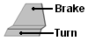
When the wheels touch, slowly allow the yoke forward so as to lower the nose tire softly. Then use the pedals to both steer and brake. With your toes you press on the upper part of the pedals to brake. With the heel you press on the lower part of the pedals to steer so you stay on the runway centerline. The left brake pedal brakes the left wheel, the right brake pedal brakes the right wheel. When you are finally down on the runway, if you’re headed OK down the runway, you’ll want to put equal soft pressure on each brake pedal, without pressing on the lower (turning) part of the pedals. For steering, however, you apply different pressure to each brake pedal (on the ground the yoke won’t work). If you’re drifting right while braking, you steer left by pressing gently with your heel on the lower part of the left pedal and applying a little extra pressure with your toes to that same pedal. These aren’t power brakes, so you’ll eventually need to press moderately hard, but start gently and uniformly to get the hang of it. To turn the engines off, pull the two levers with the red handles all the way back.
IMPORTANT
This was written by Ernie Martin for his own use. It may have errors. You use at our own risk.

