James Henderson with his ’73 P337, N576HG, 22 June 02 | 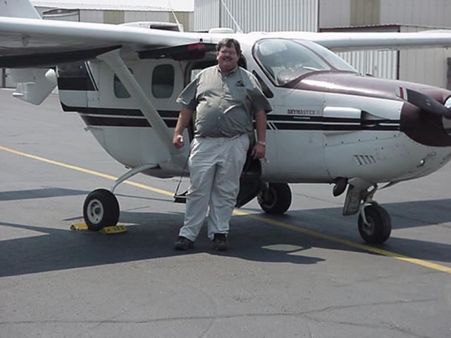
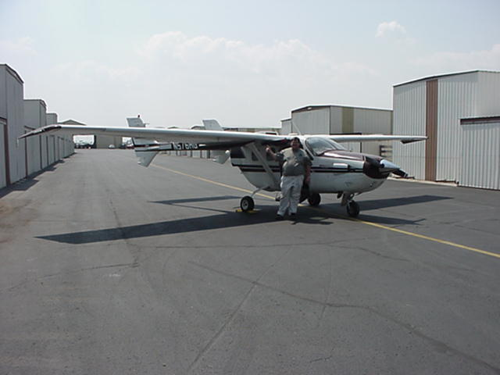
N576HG with Wing Extensions, Aux Fuel tanks by Aviation Enterprises

