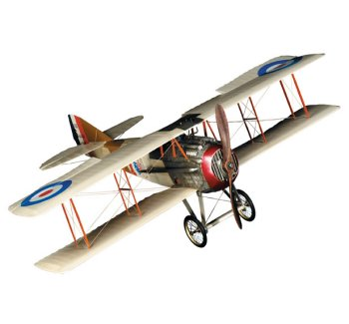

BROOKS FIELD’S
77th Anniversary
HISTORIC
FLY and DRIVE-IN
Marshall Airport / Brooks Field (KRMY)
1243 S Kalamazoo Ave, Marshall MI 49068 Phone 269-781-4447
(1.5 miles south of the fountain on the left)

Saturday Sept 6, 2008 8:00am – Noon
Pancake Breakfast
Served by “The Flying Pancakes” as seen on TV

*Fly-in is an enhancement to Marshall’s Historic Home Tour weekend
(Home Tour info: www.marshallhistoricalsociety.org )

Pancake Breakfast Air Zoo Kids Table
Vintage Planes /Waco Unmanned Helicopter
Drifters Classic Car Club Remote Control Planes/Jets
Corvette Club Hot Air Balloon Tether 8am
Antique Motorcycle Club Skydiving Demo
Aerobatic Demo 10am ** $35 Plane Rides
Aviation Colleges ** $35 Ultralight Rides
Civil Air Patrol ** $35 Helicopter Rides
Yankee Air Museum ** $70 Glider Rides

11:00 Announcements:
Hot Air Balloon Ride Raffle & Classic Car “Pilot’s Choice Award”
Door Prizes

Free Admission / Free Parking
Picnic Area / Restroom Facilities on Site
Free bus shuttle to downtown Home Tour at 11am

Sponsored by Brooks Field Aviation Association, Contact: airport@krmy.org
Phone 269-419-0332

